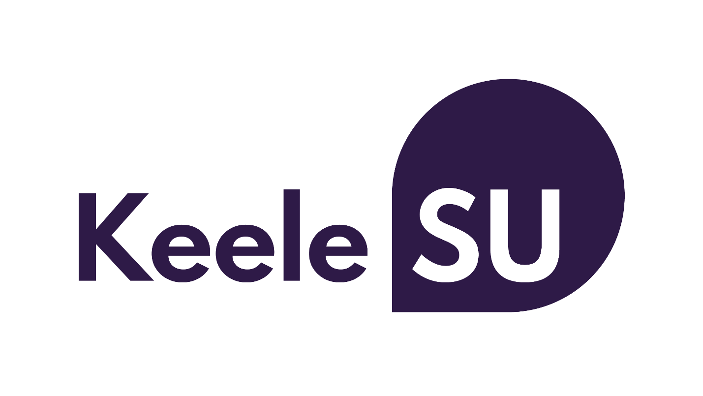

Student Data Privacy Statement

Date created: 1st May 2018
Reviewed: 22nd September 2021
Next review: 1st September 2022

Introduction
Keele University Students’ Union (“the Students’ Union”, “Keele SU”, “we”, “our” or “us”) promises to respect any personal data you share with us, or that we get from other organisations and keep it safe. We aim to be clear when we collect your data and not do anything you wouldn’t reasonably expect.

Developing a better understanding of our members through your personal data allows us make better decisions, communicate more efficiently and, ultimately, helps us to reach our goal of having a positive impact with every Keele student.

Where we collect information about you from
We collect information in the following ways:

When you become a MEMBER
Each year that you enroll on a University of Keele accredited course you automatically become a member of Keele SU, unless you opt out during enrollment or in writing, as per our constitution. The University of Keele annually shares a register of members with us which includes information about you and your course. When the University gives us this data we become responsible for it and will use this as our core central record of your membership.

When you give it to us DIRECTLY
You may give us your information in order to sign up to a student group, for one of our events, undertake research activities, use our advice service, purchase our products or communicate with us. When you give us this information we take responsibility for looking after it and we will cross reference this data against our register of members.

When you give it to us INDIRECTLY
Your information may be shared with us by independent organisations, for the University of Keele or event partners. These independent third parties will only do so when you have indicated that you have given consent to share this data with us. You should check their Privacy Policy when you provide your information to understand fully how they will process your data.

When you give permission to OTHER ORGANISATIONS to share
We may combine information you provide to us with information available from external sources in order to gain a better understanding of our members to improve our communication methods, products and services.

The information we get from other organisations may depend on your privacy settings or the responses you give, so you should regularly check them. This information comes from the following sources:

Third party organisations
You may have provided permission for a company or other organisation to share your data with third parties such as the Students’ Union. This could be when you buy a product or service, register for an online competition or sign up with a comparison site.
Social Media
Depending on your settings or the privacy policies for social media and messaging services like Facebook, WhatsApp or Twitter, you might give us permission to access information from those accounts or services.
Information available publicly
This may include information found in places such as Companies House and information that has been published in articles/ newspapers.

When we collect it as you use our WEBSITES
Like most websites, we use “cookies” to help us make our site – and the way you use it – better. Cookies mean that a website will remember you. They’re small text files that sites transfer to your computer (or phone or tablet). They make interacting with a website faster and easier – for example by automatically filling your name and address in text fields. There are more details in our Cookies Statement.
In addition, the type of device you’re using to access our website and the settings on that device may provide us with information about your device, including what type of device it is, what specific device you have and what operating system you’re using. Your device manufacturer or operating system provider will have more details about what information your device makes available to us.

When you BUY A PRODUCT from us
To place an order with us online, registration is required. At the point of registration, we request certain information including your name, delivery address and email address. This information is required to enable us to process your order and notify you of its progress. Once an order has been placed, we may contact you by email to confirm your order details and again once your order has been accepted and dispatched. Should we need to contact you for any reason regarding your order, we will use the email address registered to your account, or the telephone number where provided. We also ask if you will provide us with your Student ID number when you shop in store, this allows us to track the products you purchase, provide better customer service standards and develop the product range we offer to students.

What personal data we collect and how we use it
The type and quantity of information we collect and how we use it depends on why you are providing it.

Our Members
If you are one of our members the University, in response to their obligations to you, provide us with a set of key information you provided at enrollment. When you use our services or participate in one of our activities we will use this information to provide the best possible standards of administration and communication. The Students’ Union and the University have a Data Sharing Agreement (DSA) which outlines what data we receive and how this data can be used. The data we receive is limited to:
- Student card number
- University User ID
- Full name
- Date of birth
- Keele email address
- Nationality
- Year of Study
- Mode of Study
- Student Type (i.e. undergraduate, PGT and PGR)
- Status
- Course code
- Course name, Department name, Faculty name
- Subject
- Study site (e.g. Keele)
- Expected course end date
- Residency (i.e. type of accommodation)
- Fee status
- Term-time locality
- Mature student status
The reasons we receive this data as outlined in the DSA is for:

1. Registration of Keele Student Members with KeeleSU to become KeeleSU Members.
2. Maintenance of KeeleSU membership requirements.
3. Administration of KeeleSU elections.
4. Management of KeeleSU clubs, societies and other student opportunities.
5. Management of events and ticket sales.
6. Administration of activities and volunteering opportunities.
7. Communication between KeeleSU and KeeleSU Members.
8. Pastoral support, complaints and representation.
9. Security and discipline (including CCTV).

In addition when you attend an event, join a student group or use one of our services we may ask for additional information such as:

- Your bank details to facilitate payments
- Information relating to your health if you are taking part in a high risk activity
- Any disabilities so that we can provide assistance where needed

We may also use your data to:

- Provide you with the services, products or information you asked for
- Keep a record of your relationship with us
- Ensure we know how you prefer to be contacted
- Understand how we can improve our services, products or information
- Register your membership with National Governing Bodies where relevant details of which can be found in our NGB register, published at our Annual General Meeting (AGM)
- Register your name and email address with our insurance provider if you compete is a sports team
- To pass onto the University Covid Response Team if it is believed that you have been exposed to COVID 19 when on our premises or when taking part in one of our activities

Building profiles of members and targeting communications
We use profiling and screening techniques to ensure communications are relevant and timely, and to provide an improved experience for our members. Profiling also allows us to target our resources effectively, which members consistently tell us is a key priority for them. We do this because it allows us to understand the background of the people who study at the University and helps us to deliver appropriate services and information to members who need it.

When building a profile we may analyse geographic, demographic and other information relating to you in order to better understand your interests and preferences in order to contact you with the most relevant communications. Your data would only ever be analysed or profiled through encrypted and protected data processes, which only ever identifies broad statistics. In doing this, we may use additional information from third party sources when it is available.

How we keep your data safe and who has access
Personal data collected and processed by us may be shared with Students’ Union employees and volunteers and under strictly controlled conditions where necessary. This could include:

- Contractors
- Advisors
- Agents
- Service provider partners

When we allow access to your information, we will always have complete control of what they see, what they are allowed to do with it and how long they can see it. We do not sell or share your personal information for other organisations to use.

We undertake regular reviews of who has access to information that we hold to ensure that your information is only accessible by appropriately trained staff, volunteers and contractors.

Some of our suppliers run their operations outside the European Economic Area (EEA). Although they may not be subject to the same data protection laws as companies based in the UK, we will take steps to make sure they provide an adequate level of protection in accordance with UK data protection law. By submitting your personal information to us you agree to this transfer, storing or processing at a location outside the EEA.

We may need to disclose your details if required to the police, regulatory bodies or legal advisors.

We will only ever share your data in other circumstances if we have your explicit and informed consent.

Marketing & Communications Preferences

Membership Communications
As a member we believe you have a legitimate interest in hearing from us about the products, services and events we offer, what we’re doing to represent you and opportunities that might be of interest to you. You may opt out of these communications at any stage by clicking the unsubscribe link contained within the email.

Direct Marketing
As a charity we need to fundraise to provide the services we offer to Keele University students we do this through our trading company, which operates our bars, entertainment, catering and retail. We do not sell or share personal details to third parties for the purposes of marketing.
Sometimes we work with other organisations so you may see promotions about these in our communications, but we never share your details with these companies.

Controlling what you want to hear about
We make it easy for you to tell us how you want us to communicate, in a way that suits you. Our forms have clear marketing preference questions and we include information on how to opt out when we send you marketing. If you don’t want to hear from us, that’s fine. Just let us know when you provide your data or contact us on su.itsupport@keele.ac.uk.

Keeping your information up to date
We mostly use the record of members provided by the University of Keele to maintain accurate data about you as described above. We really appreciate it if you let us know if your contact details change.

Understanding the detail of our data security measures
When we process your data we will have already carefully assessed the lawful justification for doing so, the parameters in which the data is processed, the length of time the data is held for, the secure storage of your data and undertaken impact assessments to ensure your rights are delivered.

The Students’ Union operates a Data Protection and Information Security Policy which is supported by a practical handbook for our employees and volunteers. All employees and volunteers handling data are required to undertake general data protection training and third parties handling data are required to provide a contract which meets the requirements of the Information Commissioner's Office.

The Students’ Union does not store any sensitive card data on our systems following online transactions. The Union utilises payment processor Worldpay and ecommerce experts SagePay to handle these matters. The Students’ Union are PCI DSS compliant.

Your right to know what data we hold about you, make changes or ask us to stop using your data
You have a right to ask us to stop processing your personal data, and if it’s not necessary for the purpose you provided it to us for (e.g. processing your membership or registering you for an event) we will do so. Contact us on su.itsupport@keele.ac.uk if you have any concerns.

You have a right to ask for a copy of the information we hold about you. If there are any discrepancies in the information we provide, please let us know and we will correct them.

If you want to access your information, you must complete the Subject Access Request Form with a description of the information you want to see and the required proof of your identity by post to the Data Protection Officer, Keele University Students’ Union,Keele University, Newcastle-Under-Lyme, Staffordshire, ST5 5BJ. We do not accept these requests by email so we can ensure that we only provide personal data to the right person.

If you want to opt out of all communications, you can do so by using the unsubscribe options on all email communications, or contact su.itsupport@keele.ac.uk. If you want to opt-out of all communications and data processing you will be required to surrender your membership to the Students’ Union which will limit your access to activities and services. You can do this by contacting su.itsupport@keele.ac.uk.

If you have any questions please send these to su.itsupport@keele.ac.uk, and for further information see the Information Commissioner’s guidance here.

Changes to this statement
We may change this Privacy Statement from time to time. If we make any significant changes in the way we treat your personal information we will make this clear on our Website or by contacting you directly.

If you have any questions, comments or suggestions, please let us know by contacting su.itsupport@keele.ac.uk

