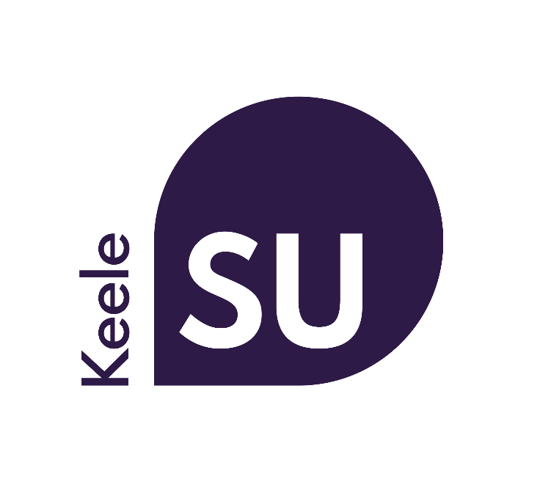

Supplier, Contractor & Client Data Privacy Statement
Date created: 1st May 2018
Reviewed on: 23rd September 2021
Next review date: 1st September 2022

Introduction
Keele University Students’ Union (“Keele SU” “we”, “our” or “us”) promises to respect any personal data you share with us, or that we get from other organisations and keep it safe. We aim to be clear when we collect your data and not do anything you wouldn’t reasonably expect.

Facilitating our legal requirements, organisation policy and services to our suppliers, contractors and clients through using your personal data allows us make better decisions, communicate more efficiently and, ultimately, ensure you receive the services required.

Where we collect information about you from
We collect information in the following ways:

When you register as a supplier or contractor
When you register as a supplier with the Students’ Union you provide us with certain personal data.

When you register a client
When you register as a client with Keele SU you provide us with certain personal data.

What personal data we collect and how we use it
The type and quantity of information we collect and how we use it depends on why you are providing it.

Suppliers and contractors
In registering as a supplier we will ask you to provide us with the following personal information:

- Name
- Address
- Email
- Telephone number
- Bank Details
- Job Title

We will mainly use your data to administer our contracted duties with you.

Clients
In establishing a contract with us as a client we will ask you to provide us with the following personal information:

- Name
- Address
- Email
- Telephone number
- Job Title

We will mainly use your data to administer our contracted duties with you and undertake credit reference checks where appropriate.

How we keep your data safe and who has access
We undertake regular reviews of who has access to information that we hold to ensure that your information is only accessible by appropriately trained staff and contractors.

Some of our suppliers run their operations outside the European Economic Area (EEA). Although they may not be subject to same data protection laws as companies based in the UK, we will take steps to make sure they provide an adequate level of protection in accordance with UK data protection law. By submitting your personal information to us you agree to this transfer, storing or processing at a location outside the EEA.

We may need to disclose your details if required to the police, regulatory bodies or legal advisors.

We will only ever share your data in other circumstances if we have your explicit and informed consent.

Keeping your information up to date
We request that suppliers, contractors and clients make best attempts to ensure data held by the Students’ Union is up to date and accurate. In the event of any changes to data or the discovery of any inaccuracies please contact su.finance@keele.ac.uk

Understanding the detail of our data security measures
When we process your data we will have already carefully assessed the lawful justification for doing so, the parameters in which the data is processed, the length of time the data is held for, the secure storage of your data and undertaken impact assessments to ensure your rights are delivered.

Keele SU operates a Data Protection and Information Security Policy which is supported by a practical handbook for our employees and volunteers. All employees and volunteers handling data are required to undertake general data protection training and third parties handling data are required to provide a contract which meets the requirements of the Information Commissioner's Office.

Your right to know what data we hold about you, make changes or ask us to stop using your data
You have a right to ask us to stop processing your personal data, and if it’s not necessary for the purpose you provided it to us for (e.g. Union policy) we will do so. Contact us at su.itsupport@keele.ac.uk if you have any concerns.

You have a right to ask for a copy of the information we hold about you. If there are any discrepancies in the information we provide, please let us know and we will correct them.

If you want to access your information, you must complete the Subject Access Request Form with a description of the information you want to see and the required proof of your identity by post to the Data Protection Officer, Keele University Students’ Union,Keele University, Newcastle-Under-Lyme, Staffordshire, ST5 5BJ. We do not accept these requests by email so we can ensure that we only provide personal data to the right person.

If you have any questions please send these to su.itsupport@keele.ac.uk, and for further information see the Information Commissioner’s guidance here (link is external).

Changes to this statement
We may change this Privacy Statement from time to time. If we make any significant changes in the way we treat your personal information we will make this clear on our Website or by contacting you directly.

If you have any questions, comments or suggestions, please let us know by contacting su.itsupport@keele.ac.uk

