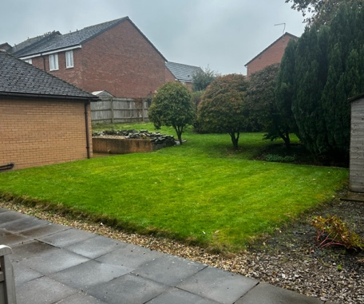
Property Overview
General Information
- Driveway: Space for 4–5 cars.
- Garden Maintenance: Regularly maintained by a gardener.
- Landlord: Lives 2 minutes away and typically responds to issues within 48 hours.
- Tenant Feedback: Landlord is described as friendly and responsive.
⸻
Tenancy Details
- Tenancy Duration: Flexible; can run from September to June if preferred but must give 2 months notice
- Rent (Every Calendar Month):
  - Main House:
    - 3 large bedrooms: £790 / month each
    - 1 small bedroom: £660 / month
  - Outhouse:
    - 2 bedrooms: £660 / month each
- Bills: Included in rent.
⸻
Main House
- Bedrooms:
  - 3 large bedrooms:
    - Double bed, mattress, desk, chair, wardrobe, bedding, and curtains.
    - Rent: £790 / month
    - Note: Photos not available as rooms were occupied when we visited so we didn’t want to invade their privacy!
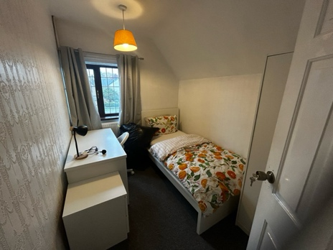
  - 1 small bedroom:
    - Single bed, mattress, bedding, desk, chair, wardrobe.
    - Rent: £165 / week
    - Note: Room is quite cramped.
- Living Room:
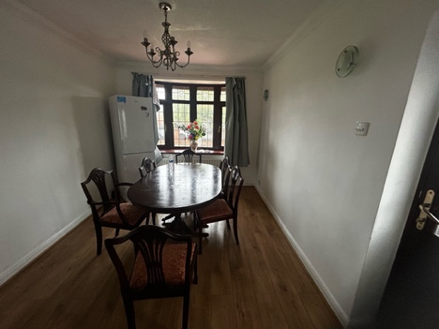
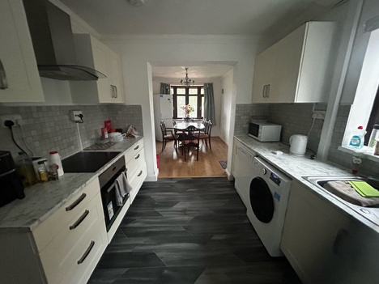
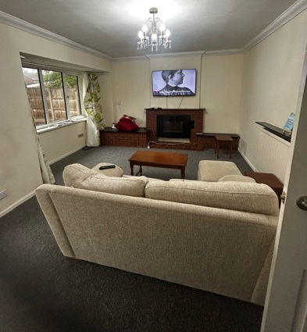
  - Includes a large TV.
- Kitchen:
  - Spacious with:
    - 1 fridge freezer
    - Washing machine
    - Dishwasher
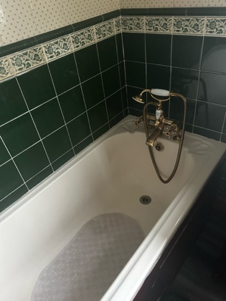
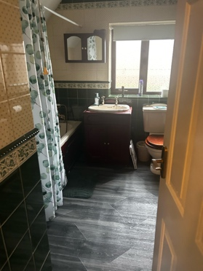
    - Toaster
    - Kettle
    - Microwave
- Bathrooms:
  - 1 bathroom with shower and toilet
  - 1 bathroom with bath and toilet
  - Note: No photo available of the shower bathroom.
⸻
Outhouse
- Bedrooms:
  - 2 decently sized rooms:
    - Single beds, mattress, bedding, wardrobe, desk, and chair.
    - Rent: £165 / week
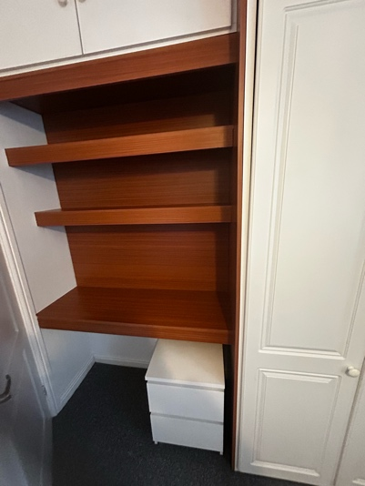
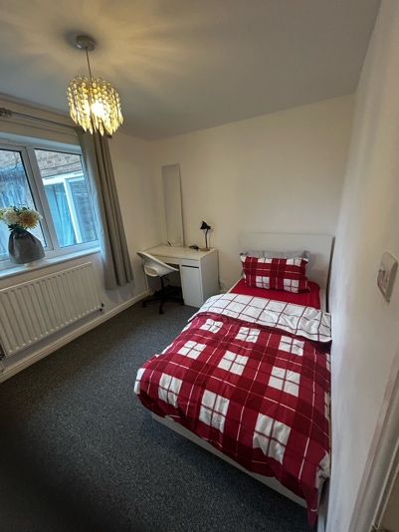
    - Note: One room currently occupied; no photo available.
- Kitchen:
  - Small kitchen with:
    - Fridge freezer
    - Toaster
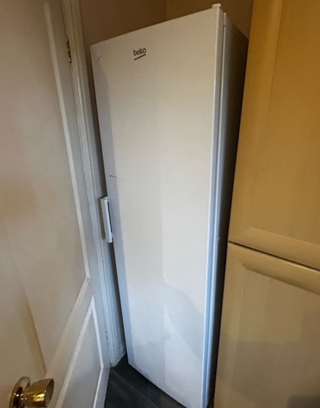
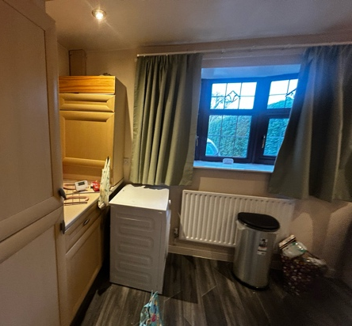
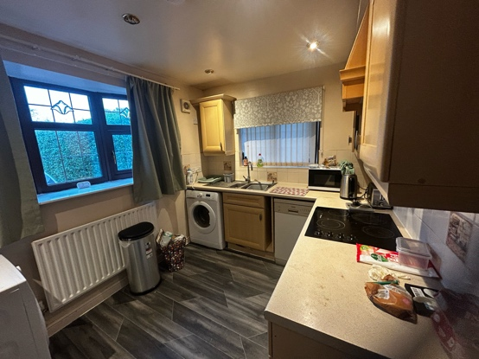
    - Other basic appliances
- Bathroom:
  - Includes shower and toilet
  - Note: No photo available.
⸻
Additional Notes
- Bus stop located directly outside the property.
⸻

